******GALGOTIAS UNIVERSITY

Plot No.2, Sector -17 A, Yamuna Expressway,

Greater Noida, Gautam Buddh Nagar, U.P., India

**DEPARTMENT OF COMPUTER SCIENCE AND ENGINEERING**

CAT-3 Group Activity Report File Submission

# Course Name: Semi-conductor Physics

CourseCode: BBS01T1002

School: SCSE

Session: 2021-2022

|  |  |
| --- | --- |
| Submitted By: | Submitted To: |
| SHIVAM DWIVEDI  21SCSE1010662 | Anis Ahmad |

Program： B.Tech CSE Semester：I

**Name of Topic: Photo Voltic Effect Solar Cell**

**Name: Shivam Dwivedi (21scse1010662)**

**Satvik Shukla (21SCSE1010146)**

**Saurabh sah(21SCSE1011305)**

**Saurabh Sharma (21SCSE1010780)**

**Group Number:15 Section:7**

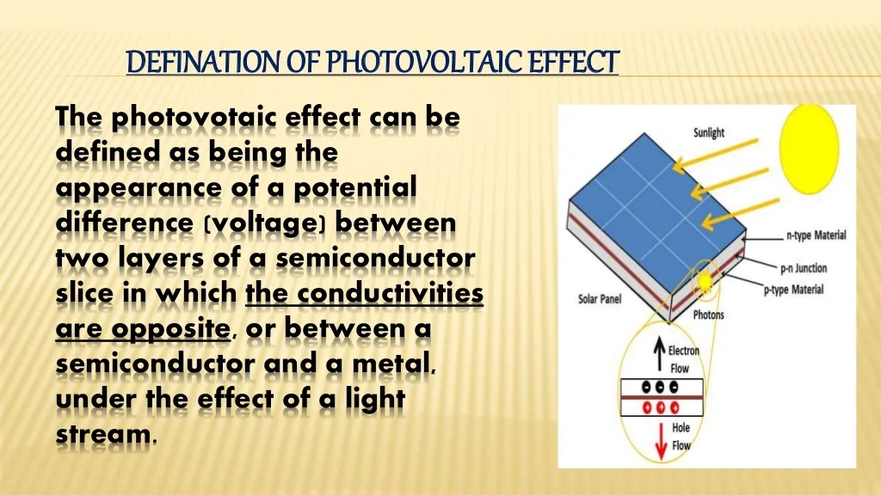

SHIVAM DWIVEDI 21SCSE1010662

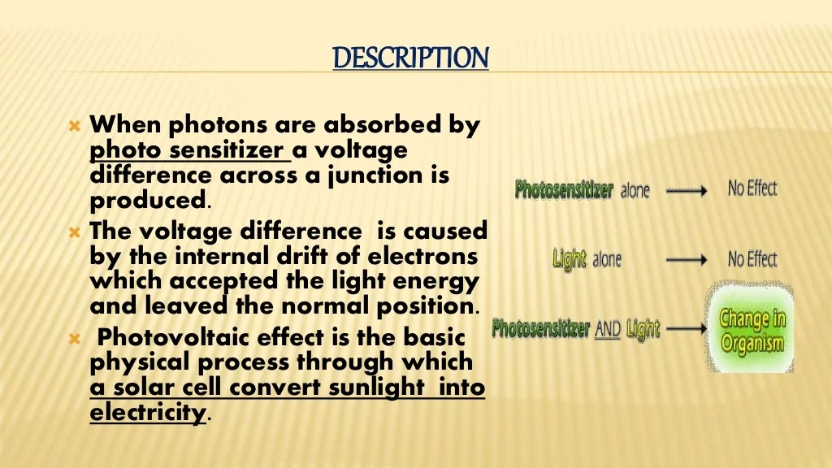

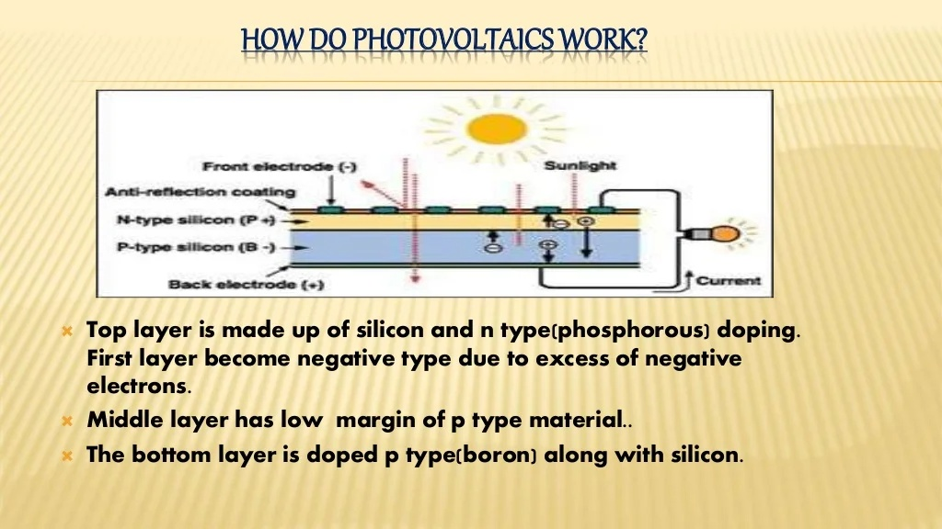

**Write steps involved in designing component in software & attach screenshot**

**THANKS & REGARDS**

SHIVAM DWIVEDI 21SCSE1010662